COMP315 – SEMESTER PROJECT
PROJECT PROPOSAL
Multi-Threaded Real-Time Inventory & Trading System

StationaryHub

Member Name | Student ID | Role | % Contribution
Bandile Mhlambu | 223022585 | Project Manager | 14.28%
Sbonelo Ntshangase | 223012027 | STL & Data Structures | 14.28%
Lerato Mbhele | 221053528 | UI Design & Memory Management | 14.28%
Bongani Ntshumayelo | 222128837 | Software Code | 14.28%
Lindokuhle Machangu | 221032601 | Unit Testing & Logic Implementation | 14.28%
Andile Mthembu | 223043890 | Documentation | 14.28%
Sthembiso Mchunu | 224144451 | Class and System Architecture Design | 14.28%

1. System Introduction1.1 System Overview
The StationaryHub Inventory and Trading System is a multi-warehouse inventory management system that is designed to manage different stationery products such as calculators, pens, pencils, and exercise books supplied from different warehouses.

The system is connected to nine warehouses, each warehouse holds a large quantity of different kinds of products and maintain its own stock quantity and storage capacity. The system adds the details of each product and the quantity of each product in the warehouse. When there's a shortage of a product's stock, the system has a function to add the product's stock in the warehouse.

The warehouse will be updated while ensuring that there is enough capacity to store the stock. The system keeps track of how much space(capacity) each warehouse has for storing products. When there is a taxable product, the system increases the price of the product by the percentage it should be taxed by. When there is a discountable product, the system reduces the price of the product by the percentage it should be discounted by. When a customer buys in bulk, the system reduces the price of the product. The system rejects an order if the quantity of the product exceeds the quantity of the available product in the warehouse.

Since the company is located in multiple provinces with a large customer base, the system uses the concept of multithreading to allow the enterprise to handle any influx of orders concurrently ,making order processing quicker and more efficient. multiple customers may attempt to purchase the same products simultaneously, using proper synchronization concurrent access to share inventory we prevent race condition, incorrect stock update and negative stock values.

2. System Requirements

2.1 Functional Requirements
- FR-1:
The system will allow an administrator to add a new warehouse with a unique ID and province name.
- FR-2:
The system will allow an administrator to remove an existing warehouse by its ID.
- FR-3:
The system will display all warehouses and their full product inventory.
- FR-4:
The system will allow a new product to be added to a specific warehouse, specifying product type (Taxable, Discount, or Bulk), price, and initial stock quantity.
- FR-5:
The system will allow a product to be removed from a specific warehouse by its product ID.
- FR-6:
The system will support searching for a product within a warehouse by product ID.
- FR-7:
The system will process at least 20 customer orders concurrently using multithreading, where each order targets a specific product and quantity.
- FR-8:
The system will fulfil an order by reducing stock if sufficient quantity exists, or reject it with a FAILED status if not.
- FR-9:
The system will display each thread's ID, the product ordered, the fulfilling warehouse, and the order outcome (SUCCESS or FAILED).
- FR-10:
The system will load initial inventory from an inventory.csv file at startup, falling back to hard-coded defaults if the file is not found.
- FR-11:
The system will track warehouse capacity

Non-Functional Requirements
- NFR-1:
To ensure thread safety, all shared inventory data must be protected using mutex and standard lock guard and there must be no race conditions or data corruption shall occur under concurrent access.
- NFR-2:
To guarantee memory safety, no raw pointers, new, or delete are permitted. All dynamic objects must use shared pointer.
- NFR-3:
In terms of performance, the system must handle at least 20 concurrent order threads without deadlocks, crashes, or incorrect stock values.
- NFR-4:
To ensure correctness stock levels must never become negative. Insufficient-stock orders must be rejected before deduction.
- NFR-5:
In the case compilation, the project must compile without warnings.
- NFR-6:
To ensure adequate capacity, the system must support at least 15 distinct products and 20 total orders as required by the project specification.
- NFR-7:
To guarantee smooth usability, the CLI menu must be clearly labelled. All output must include thread IDs for multi-threaded operations to demonstrate visible concurrency.
- NFR-8:
To ensure robustness, invalid inputs (non-existent warehouse ID, missing product) must produce clear error messages without crashing.

3. System Architecture

3.1 High-Level Architecture
StationaryHub is structured in six distinct layers. Each layer has a single responsibility, and communication flows downward - the CLI calls the manager, which delegates to the warehouses, which own the products.

Component | Layer | Responsibility
CLI / main.cpp | User Interface Layer | Menu-driven input/output
InventoryManagementSystem | Manager Layer | Manages all warehouses
Warehouse (x9) | Warehouse Layer | Per-province stock + mutex
Product / TaxableProduct DiscountProduct / BulkProduct | Domain Layer | OOP product hierarchy
Order | Concurrency Layer | 20 threads, mutex-protected
inventory.csv | Persistence Layer | CSV or hard-coded startup data
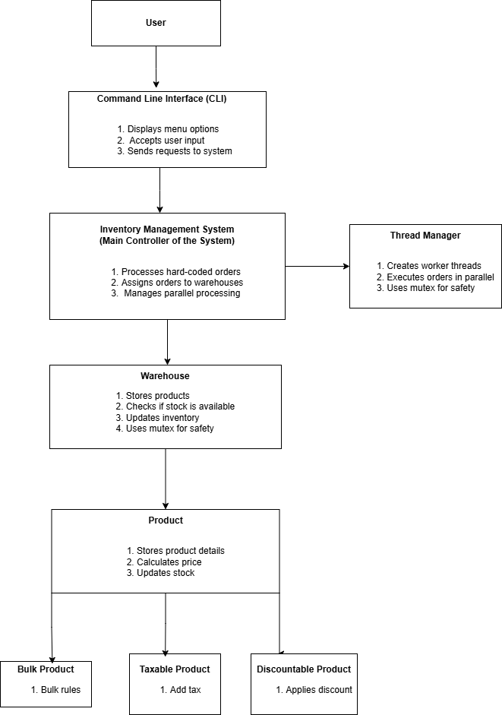

Data Flow
The user interacts with the Command Line Interface.
The Command Line Interface sends requests to the Inventory Management System.
The system processes hard-coded orders.
Orders are assigned to warehouses.
Orders may be processed sequentially or in parallel using threads.
Mutex locks protect shared resources (inventory and active orders).
Warehouse updates product stock safely.
Results return to the user.

Concurrency & Memory Management
Concurrency Design
Multiple orders can be processed in parallel.
Threads are used for concurrent execution.
Mutex locks protect:
Warehouse inventory
Active order list

Memory Management
Smart pointers are used to manage:
Warehouses
Products
Prevents memory leaks.
Ensures safe object ownership.

4. Class Design & OOP Structure

4.1 Class Descriptions

Class | Type | Key Attributes | Key Methods
Product | Abstract base class | productID, name, basePrice | calculateFinalPrice() [pure virtual], display(), getID(), getName(), getBasePrice()
TaxableProduct | Derived from Product | taxRate | calculateFinalPrice(): price * qty * (1 + taxRate)
DiscountProduct | Derived from Product | discountRate | calculateFinalPrice(): price * qty * (1 - discountRate)
BulkProduct | Derived from Product | threshold, bulkDiscount | calculateFinalPrice(): applies discount if qty >= threshold
Warehouse(one for each province) | Composition target | warehouseID, location, map<int,StockItem>, mutex | addProduct(), removeProduct(), decreaseStock(), displayAllProducts(), searchProduct()
InventoryManagementSystem | Manager | vector<shared_ptr<Warehouse>> | addWarehouse(), removeWarehouse(), displayAllWarehouses(), findWarehouse()
Order | Value object | orderID, province, vector<OrderItem>, status | addItem(), getItems(), setStatus(), getStatus()
OrderItem | Struct | productID, quantity | constructor

4.2 UML Class Diagram
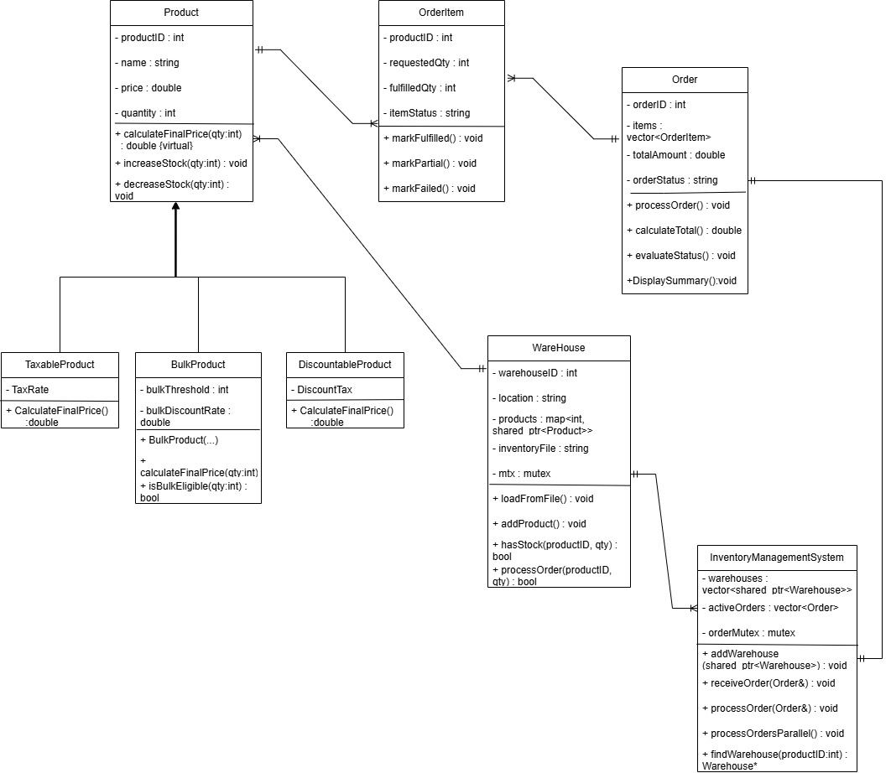

4.3 Inheritance and Polymorphism
The Product class declares calculateFinalPrice(int quantity) as a pure virtual method (= 0), making it an abstract class that cannot be instantiated directly. All three derived classes - TaxableProduct, DiscountProduct, and BulkProduct -override this method with their own pricing logic:

Product
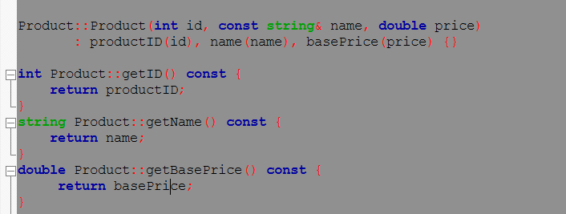

TaxableProduct: Adds Tax
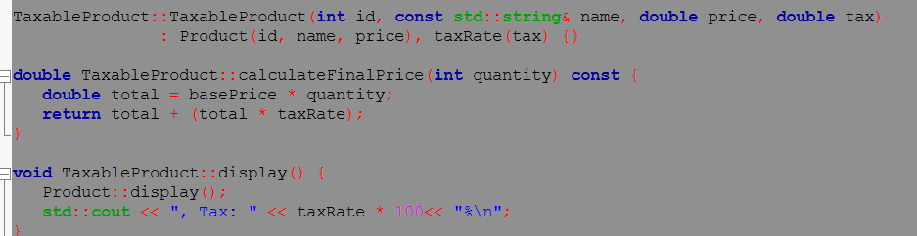

DiscountProduct: subtracts discount
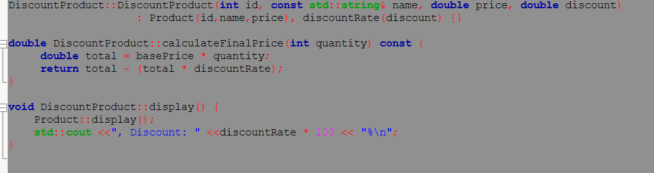

BulkProduct: discount only applied if qty >= threshold
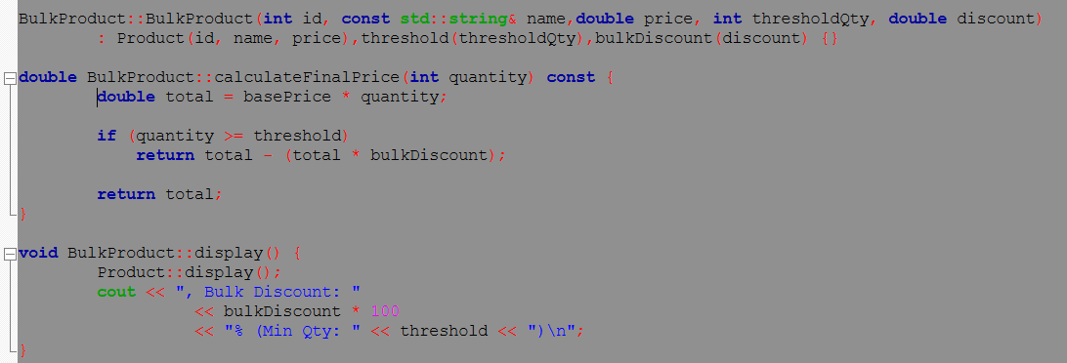

When Warehouse::displayAllProducts() iterates through its inventory map and calls product->display(), C++ virtual dispatch automatically calls the correct overridden version - this is polymorphism in action. Without virtual functions, the base class version would always be called regardless of the actual object type.

5. Data Structures & STL Usage

5.1 Containers Used

1. std::vector

The system stores the collection of warehouses using std::vector. Each element in the vector represents a warehouse object containing its own product stock levels, storage capacity, and product collection. The use of vector allows easy indexing, dynamic sizing, and sequential access. std::vector is compatible with std::find_if for searching. For this, std::vector offers a simple and efficient container, since the number of warehouses is fixed.

2. std::map

Products are stored in each warehouse using std::map, where the value represent product item, and the key is a unique Product ID. The use of std::map is good for product storage since it ensures unique keys, supports efficient searching, and it ensures that duplicate product IDs cannot exist within the same warehouse.

5.2 STL Algorithms
std::find_if
This is used when we are looking for a warehouse using its ID.
This function searches the list and picks the warehouse that matches the entered ID.
This function makes the code more readable.

std::map::find
This is used when we are looking for a product within a warehouse.
Because products are stored in a map data structure, this function enables the system to easily find a product based on its key.
This is much faster than manually scanning each product one by one, especially when there are many products.

std::sort
This is used when we are looking to sort products.
For example, products can be sorted based on their price or quantity.
This makes it easier for the user to display products in an organized way.

5.3 Why std::map for Product Storage
std::map enforces unique keys, which maps perfectly to the requirement that each product ID is unique within a warehouse. It provides O(log n) insertion, deletion, and lookup — far better than a linear search through a vector for a product ID. The automatic key-ordering also means products are always displayed in ascending ID order without any additional sorting step.

6. Concurrency Design

6.1 Threading Model
StationaryHub uses multiple threads to process orders. When the user selects Process All Orders, the system creates threads for each order. After creating all threads, the program calls join() on each thread. This means that all orders will run at the same time. This makes processing faster.

6.2 Shared Resources and Synchronization
The main shared resource is the warehouse inventory:
std::map<int, StockItem>
Many threads may access the inventory at the same time. To prevent this problem, each warehouse has a std::mutex called inventoryMutex. Before reading or changing stock, the program uses:
std::lock_guard<std::mutex>
This automatically locks and unlocks when the function ends. This keeps inventory safe.

6.3 Preventing Race Conditions
To prevent race conditions, the program locks the inventory while it checks if the product exists, checks if enough stock is available, and reduces the stock. Because all steps happen inside one locked section, no other thread can interrupt. Stock cannot go below zero and data stays correct.

6.4 Console Output Protection
Many threads print to the console. Without protection, messages can mix together. A second mutex called consoleMutex is used. Before printing with std::cout, the thread locks this mutex. This ensures one full message prints at a time and output stays clear.

7. Memory Management Strategy
The system uses smart pointers only. There are no raw new or delete statements anywhere in the program. This reduces errors and make the system more stable.

7.1 Smart Pointer Usage
std:: shared_ptr<Product> is used because products may be shared in different parts of the system, such as the warehouse inventory and order processing. The product will stay in memory as long as it is being used.
std::shared_ptr<Warehouse> is used because warehouses contain a std::mutex, and objects with a mutex cannot be copied. Using shared_ptr allows warehouses to be safely stored and accessed without copy problems. std::shared_ptr
std::shared_ptr<Order> is used std::shared_ptr<Order> is used to ensure orders stay in memory while threads are running. Even if multiple parts of the system access the same order, it remains valid until processing is complete.

7.2 Why Raw Pointers Are Not Used
Raw pointers require manual memory management using delete. If delete is forgotten, it causes a memory leak. If it is used incorrectly, it can cause crashes or serious program errors. These problems are common in large systems.
Smart pointers manage memory automatically. When the last shared_prt pointing to an object goes out of scope, the object is deleted safely. This makes the program more reliable and easier to maintain.

7.3 Memory at Program End
When main() ends, all shared_prt objects go out of scope. Their reference counts become zero, and the objects are destroyed automatically. This includes all Product, Warehouse, and Order objects.
Because memory is handled automatically, there are no memory leaks left when the program finishes.

8. User Interface Design

8.1 CLI Menu Structure
The application presents a text-based menu on startup. The menu is divided into three sections: Warehouse Operations, Product Operations, and Order Processing. The user enters a single integer to select an option, and the system responds with clear prompts and confirmation messages.
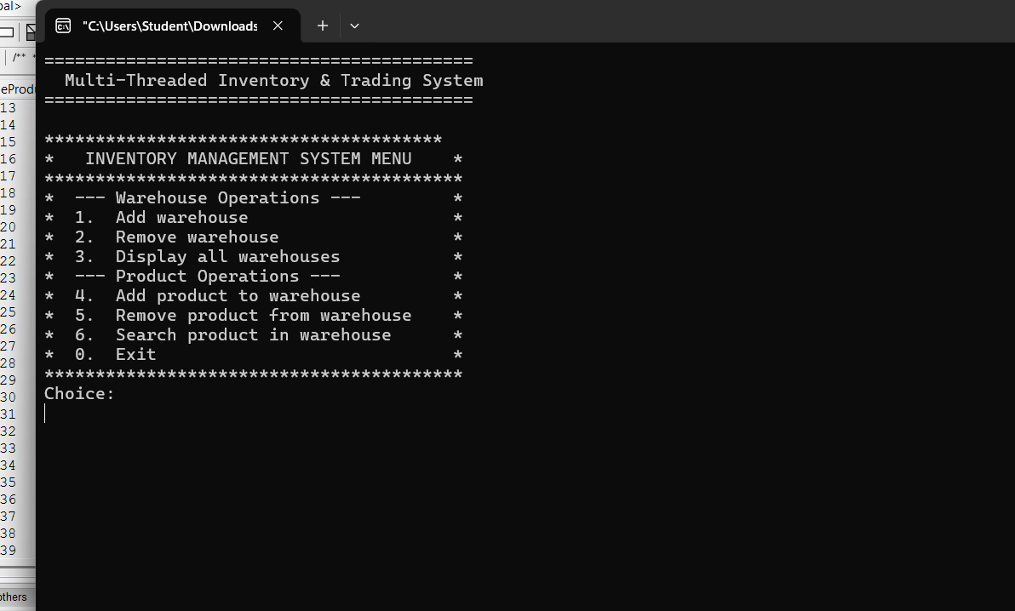_
*Sort Product By Price And
*Process Customer Order

8.2 Expected Thread Output
When option 7(not yet implemented) is selected, the system spawns 20 threads and prints each thread's activity as it executes. The thread IDs in the output are different OS-assigned values, and the interleaved order confirms simultaneous execution.

9. Implementation Plan & Milestones

9.1 Milestone Table

Phase | Due Date | Deliverables | Responsible
Phase 1 | Feb 25, 2026 | Product class hierarchy, Warehouse, IMS, CLI menu, CSV loader | Member 1 + Member 3
Presentation 1 | Feb 27 / Mar 4 | Present Phase 1 design and initial code | All members
Phase 2 | Mar 26, 2026 | multithreading, mutex synchronization, 20 orders | Member 2 + Member 5
Phase 3 | Apr 29, 2026 | Full system, 15+ products, file logging (optional), final report | All members
Presentation 3 | May 6–8, 2026 | Live demo and Q&A | All members

9.2 Task Breakdown
Bandile Mhlambu, Sbonelo and Lindokuhle Machangu were focused on the documentation.
There we focused on the introduction, system requirements, system architecture.
Leraro Mbhele, Sthembiso Mchunu, Andile Mthembu and Bongani Ntshumayelo we’re focused on creating diagrams and implementing the code (pointers, containers, etc).

10. Risks & Challenges
Race Conditions
Multiple threads may attempt to acquire the same product from the same warehouse concurrently, concurrent stock quantity updates may lead to negative stock if there is Improper synchronisation. For instance, if two threads read the same stock value before updating it, they may both process orders that exceed the available stock. To avoid this, correct synchronisation mechanisms must be used while updating product quantities.

Deadlocks
Since the system may include locking warehouse data during order processing and stocking, poor management could force threads to wait forever for one another. For instance, if one thread locks a warehouse while another thread waits for access to the same resource, improper locking may cause the system to freeze.

STL Misuse
Improper use of STL containers without proper synchronization can cause undefined behaviour. Since the system has multiple warehouses and products, using STL data structures, without proper synchronization, may result in undefined behaviour, which may cause incorrect stock updates, orders may disappear, program may randomly crash (lost product records).

11. Conclusion
Final System Overview
StationaryHub is a well-defined system that is fully specified and scoped to meet all requirements specified in the COMP315 project. It is a correct application of advanced Object-Oriented Programming concepts through a polymorphic product hierarchy. It is a correct usage of STL containers and algorithms. It is a correct solution for safe multithreaded order processing with the use of std::thread and std::mutex.
All design choices have been made with careful consideration. It has already been implemented, compiled successfully with no compiler warnings, and tested with correct interleaved thread output for all 20 orders.
Readiness to Proceed with Implementation
Since this is the Phase 1 submission for the COMP315 group project, the Product base class and all three derived classes (TaxableProduct, DiscountProduct, BulkProduct) have been fully implemented, correct, and compiling successfully. So have the Warehouse class, the InventoryManagementSystem class, and the CLI menu.
We are more than ready to proceed with the implementation phase of the project (Phase 2) to showcase the concurrent order processing.
Expected Learning Outcomes
By completing this project, all members of this group have learned how to use polymorphism in C++, how to use STL containers and smart pointer memory management, and how to implement safe multithreaded concurrent programming.

